4.2 Proposed Solution
Date | 10 July 2026
Team ID
Project Name | Book a Doctor App
Maximum Marks | 2 Marks

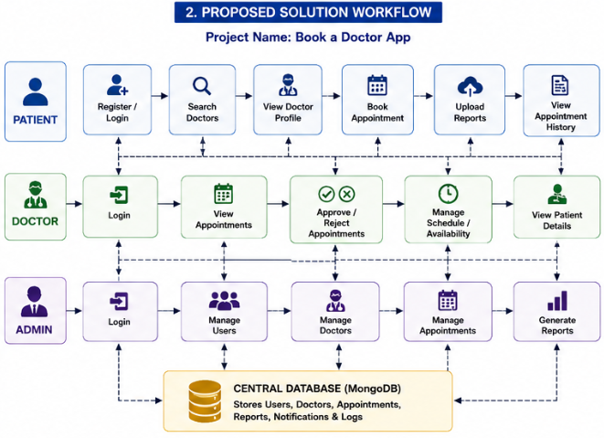

S.No | Parameter | Description
1 | Problem Statement (Problem to be solved) | Patients experience difficulties in booking doctor appointments due to manual scheduling, long waiting times, and lack of centralized healthcare management. Doctors and administrators also face challenges in managing appointments efficiently.
2 | Idea / Solution Description | Develop a web-based Book a Doctor App using the MERN Stack that enables patients to register, search doctors, book appointments, upload medical reports, and manage appointment history. Doctors can manage their schedules, while administrators oversee the complete system.
3 | Novelty / Uniqueness | The application combines role-based access, secure JWT authentication, appointment management, and digital medical record support within a single platform, improving convenience and operational efficiency.
4 | Social Impact / Customer Satisfaction | The solution reduces hospital waiting time, improves healthcare accessibility, enhances patient satisfaction, and enables better communication between patients and doctors.
5 | Business Model (Revenue Model) | Revenue can be generated through hospital subscriptions, premium doctor accounts, featured listings, and future integration of online consultation and payment services.
6 | Scalability of the Solution | The MERN Stack architecture supports scalability, allowing the system to accommodate more users, hospitals, and additional healthcare services in the future.

